Lab 4 Work Sheet (Upload to Titanium when finished) Name: Brandon Hoang
Signal Propagation Delays Date: 11/03/17
EGCP 281: Designing with VHDL

You may discuss this assignment with others, but this assignment must be completed individually.
Please recall that academic dishonesty will not be tolerated. By submitting this assignment, you understand penalties will be assessed if you submit work for credit that is not your own.

Due Date: Friday, November 3 by 12:45 PM
Submit a printout of your lab cover sheet either during lab or slide your lab work under the instructor’s office door (E-211) prior to the due date.
Upload your lab work sheet to Titanium prior to the due date.

No Prelab Problems This Lab

VHDL Code:
Copy-paste your VHDL design module code (I do not need your test bench code) for:
- The SOP expression with the timing hazard (Problem 1, Project 8):

library IEEE;
use IEEE.STD_LOGIC_1164.ALL;

entity p1 is
Port ( A : in STD_LOGIC;
B : in STD_LOGIC;
C : in STD_LOGIC;
notG: out STD_LOGIC;
andG: out STD_LOGIC;
andG2: out STD_LOGIC;
Y : out STD_LOGIC);
end p1;

architecture Behavioral of p1 is
signal a1, b1, c1: STD_LOGIC;
begin
notG <= (not A) after 1ns;
a1 <= (not A) after 1ns;
andG <= a1 and B after 1ns;
b1 <= a1 and B after 1ns;
andG2 <= A and C after 1ns;
c1 <= A and C after 1ns;
Y <= b1 or c1 after 1ns;

end Behavioral;

- The SOP expression with increased OR gate delay (Problem 4, Project 8):

library IEEE;
use IEEE.STD_LOGIC_1164.ALL;

entity p1 is
Port ( A : in STD_LOGIC;
B : in STD_LOGIC;
C : in STD_LOGIC;
notG: out STD_LOGIC;
andG: out STD_LOGIC;
andG2: out STD_LOGIC;
Y : out STD_LOGIC);
end p1;

architecture Behavioral of p1 is
signal a1, b1, c1: STD_LOGIC;
begin
notG <= (not A) after 1ns;
a1 <= (not A) after 1ns;
andG <= a1 and B after 1ns;
b1 <= a1 and B after 1ns;
andG2 <= A and C after 1ns;
c1 <= A and C after 1ns;
Y <= b1 or c1 after 2ns;

end Behavioral;

- The SOP expression with the extra logic gate in order to eliminate the timing hazard (Problem 2, Project 8):

library IEEE;
use IEEE.STD_LOGIC_1164.ALL;

entity p1 is
Port ( A : in STD_LOGIC;
B : in STD_LOGIC;
C : in STD_LOGIC;
notG: out STD_LOGIC;
andG: out STD_LOGIC;
andG2: out STD_LOGIC;
andG3: out STD_LOGIC;
Y : out STD_LOGIC);
end p1;

architecture Behavioral of p1 is
signal a1, b1, c1, d1: STD_LOGIC;
begin
notG <= (not A) after 1ns;
a1 <= (not A) after 1ns;
andG <= a1 and B after 1ns;
b1 <= a1 and B after 1ns;
andG2 <= A and C after 1ns;
c1 <= A and C after 1ns;
andG3 <= B and C after 1ns;
d1 <= B and C after 1ns;
Y <= b1 or c1 or d1 after 1ns;

end Behavioral;

- Your POS expression with the timing hazard (Problem 3, Project 8):

library IEEE;
use IEEE.STD_LOGIC_1164.ALL;

entity p1 is
Port ( A : in STD_LOGIC;
B : in STD_LOGIC;
C : in STD_LOGIC;
notG: out STD_LOGIC;
orG: out STD_LOGIC;
orG2: out STD_LOGIC;
orG3: out STD_LOGIC;
Y : out STD_LOGIC);
end p1;

architecture Behavioral of p1 is
signal a1, b1, c1, d1: STD_LOGIC;
begin
notG <= (not A) after 1ns;
a1 <= (not A) after 1ns;
orG <= A or B after 1ns;
b1 <= A or B after 1ns;
orG2 <= a1 or C after 1ns;
c1 <= a1 or C after 1ns;
orG3 <= B or C after 1ns;
-- d1 <= B or C after 1ns;
Y <= b1 and c1 after 1ns;

end Behavioral;

- Your POS expression with the extra logic gate in order to eliminate the timing hazard (Problem 3, Project 8):

library IEEE;
use IEEE.STD_LOGIC_1164.ALL;

entity p1 is
Port ( A : in STD_LOGIC;
B : in STD_LOGIC;
C : in STD_LOGIC;
notG: out STD_LOGIC;
orG: out STD_LOGIC;
orG2: out STD_LOGIC;
orG3: out STD_LOGIC;
Y : out STD_LOGIC);
end p1;

architecture Behavioral of p1 is
signal a1, b1, c1, d1: STD_LOGIC;
begin
notG <= (not A) after 1ns;
a1 <= (not A) after 1ns;
orG <= A or B after 1ns;
b1 <= A or B after 1ns;
orG2 <= a1 or C after 1ns;
c1 <= a1 or C after 1ns;
orG3 <= B or C after 1ns;
d1 <= B or C after 1ns;
Y <= b1 and c1 and d1 after 1ns;

end Behavioral;

Simulation Screenshot:
Use the “Print Screen” button to capture your screenshot (it should show the entire screen, not just the window of the program).
- The SOP expression with the timing hazard (Problem 1, Project 8):

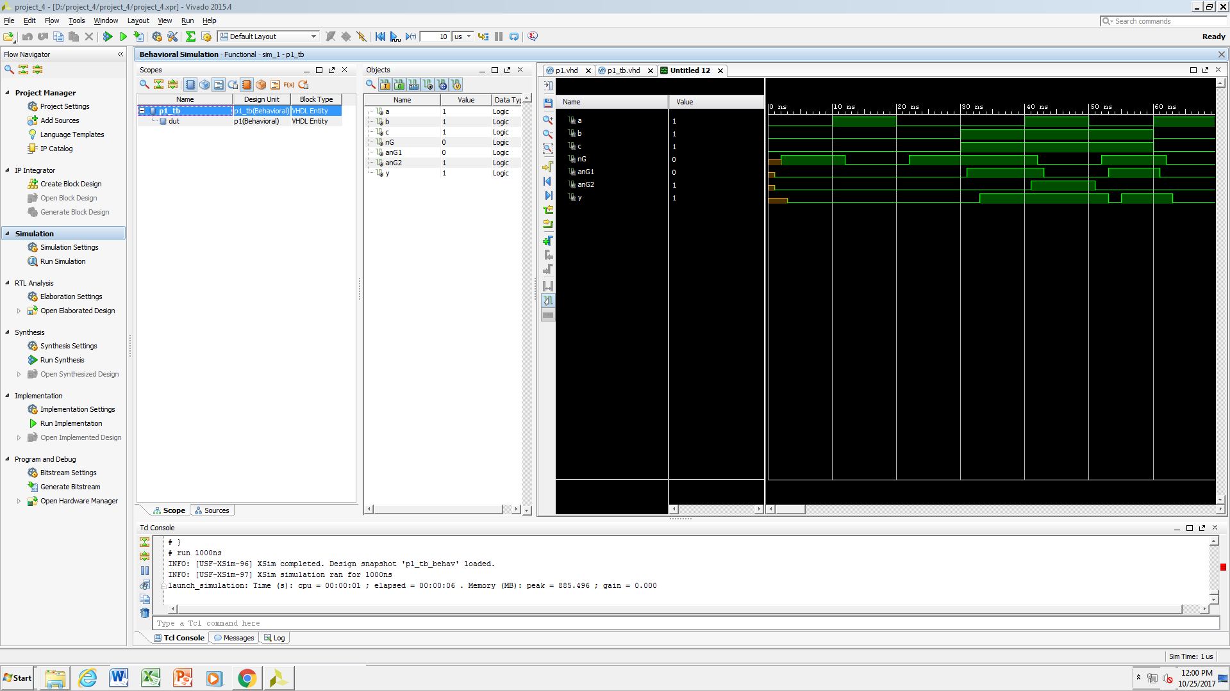

- The SOP expression with increased OR gate delay (Problem 4, Project 8):

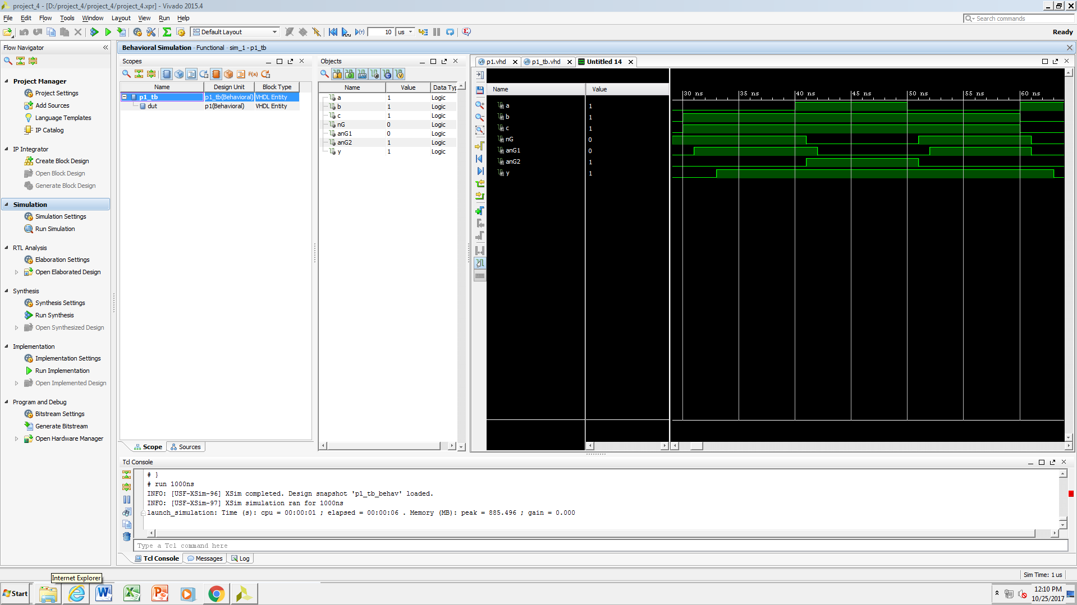

- The SOP expression with the extra logic gate in order to eliminate the timing hazard (Problem 2, Project 8):

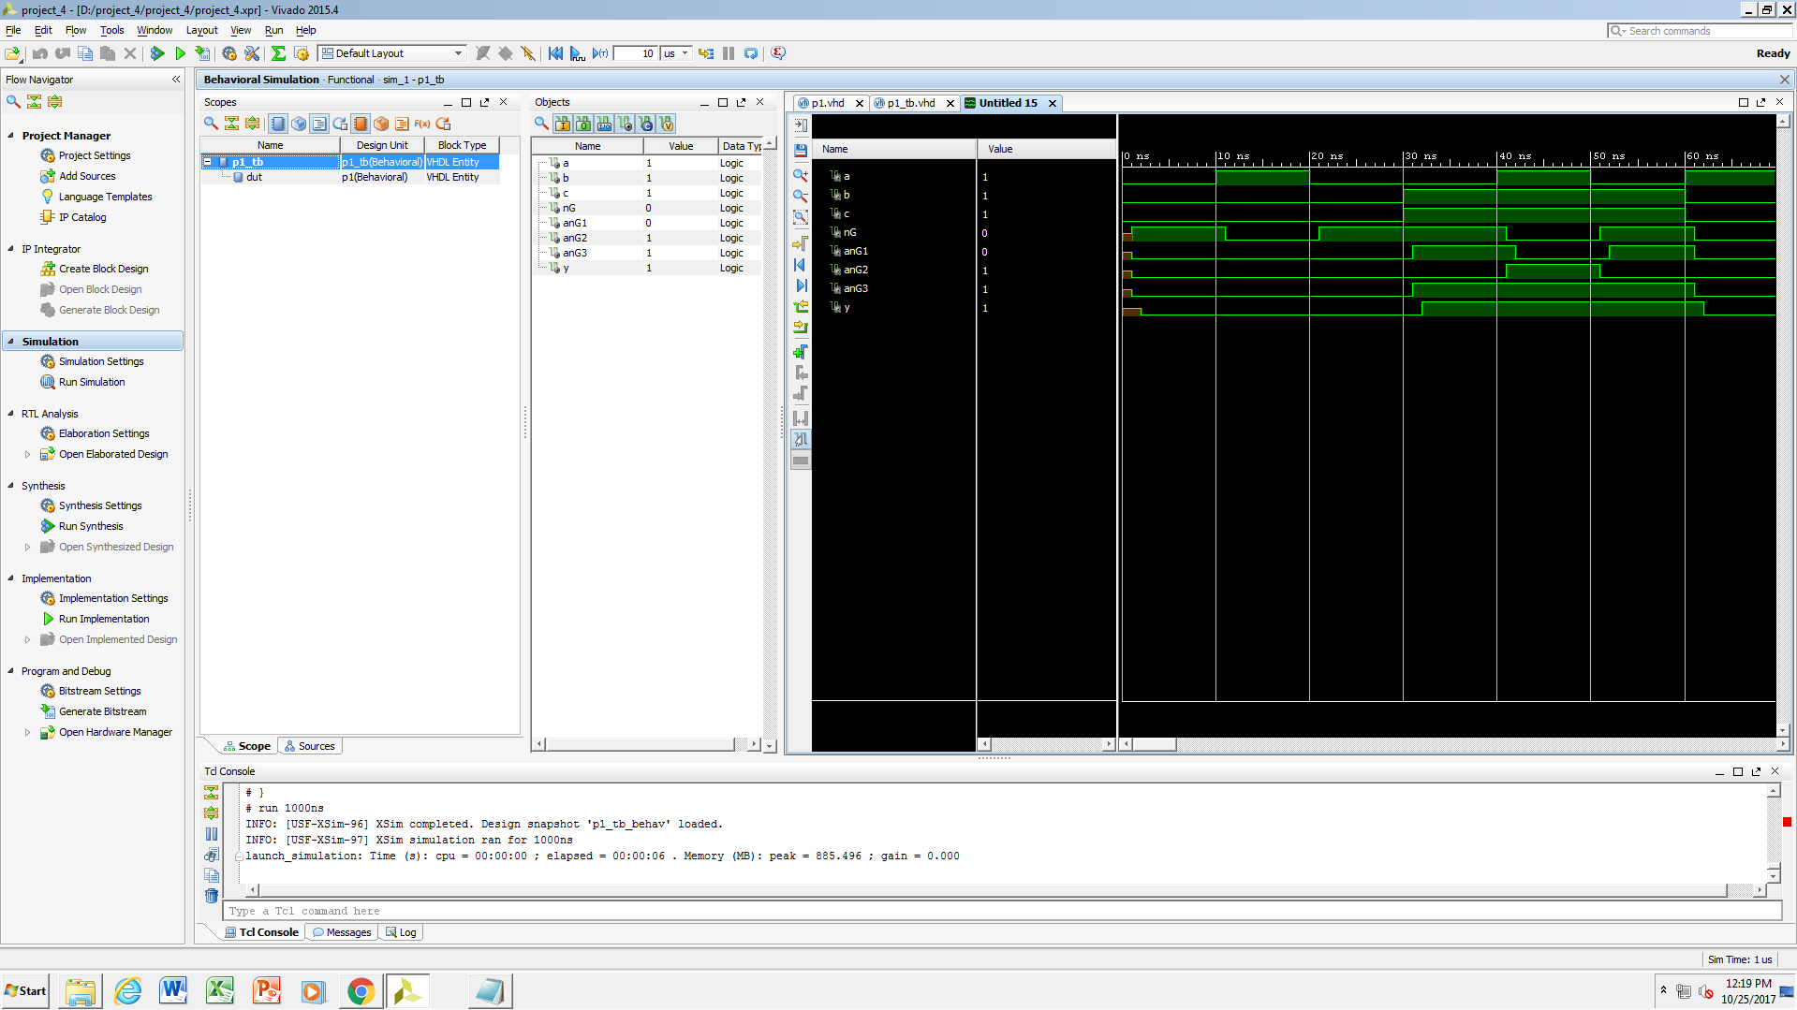

- Your POS expression with the timing hazard (Problem 3, Project 8):

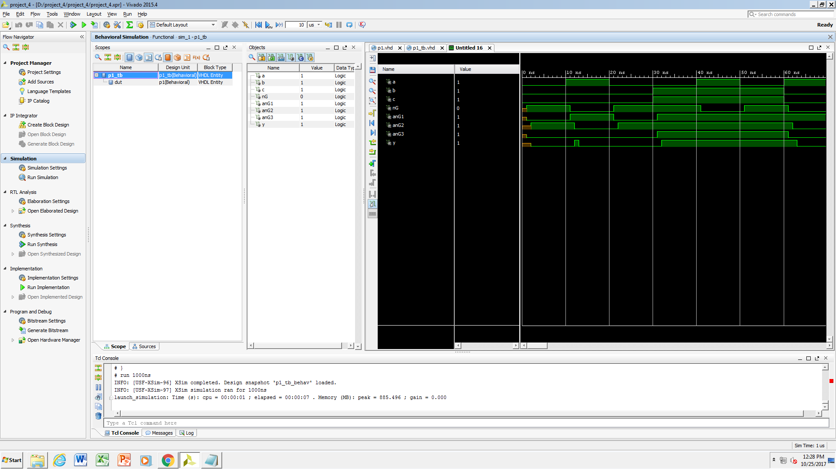

- Your POS expression with the extra logic gate in order to eliminate the timing hazard (Problem 3, Project 8):

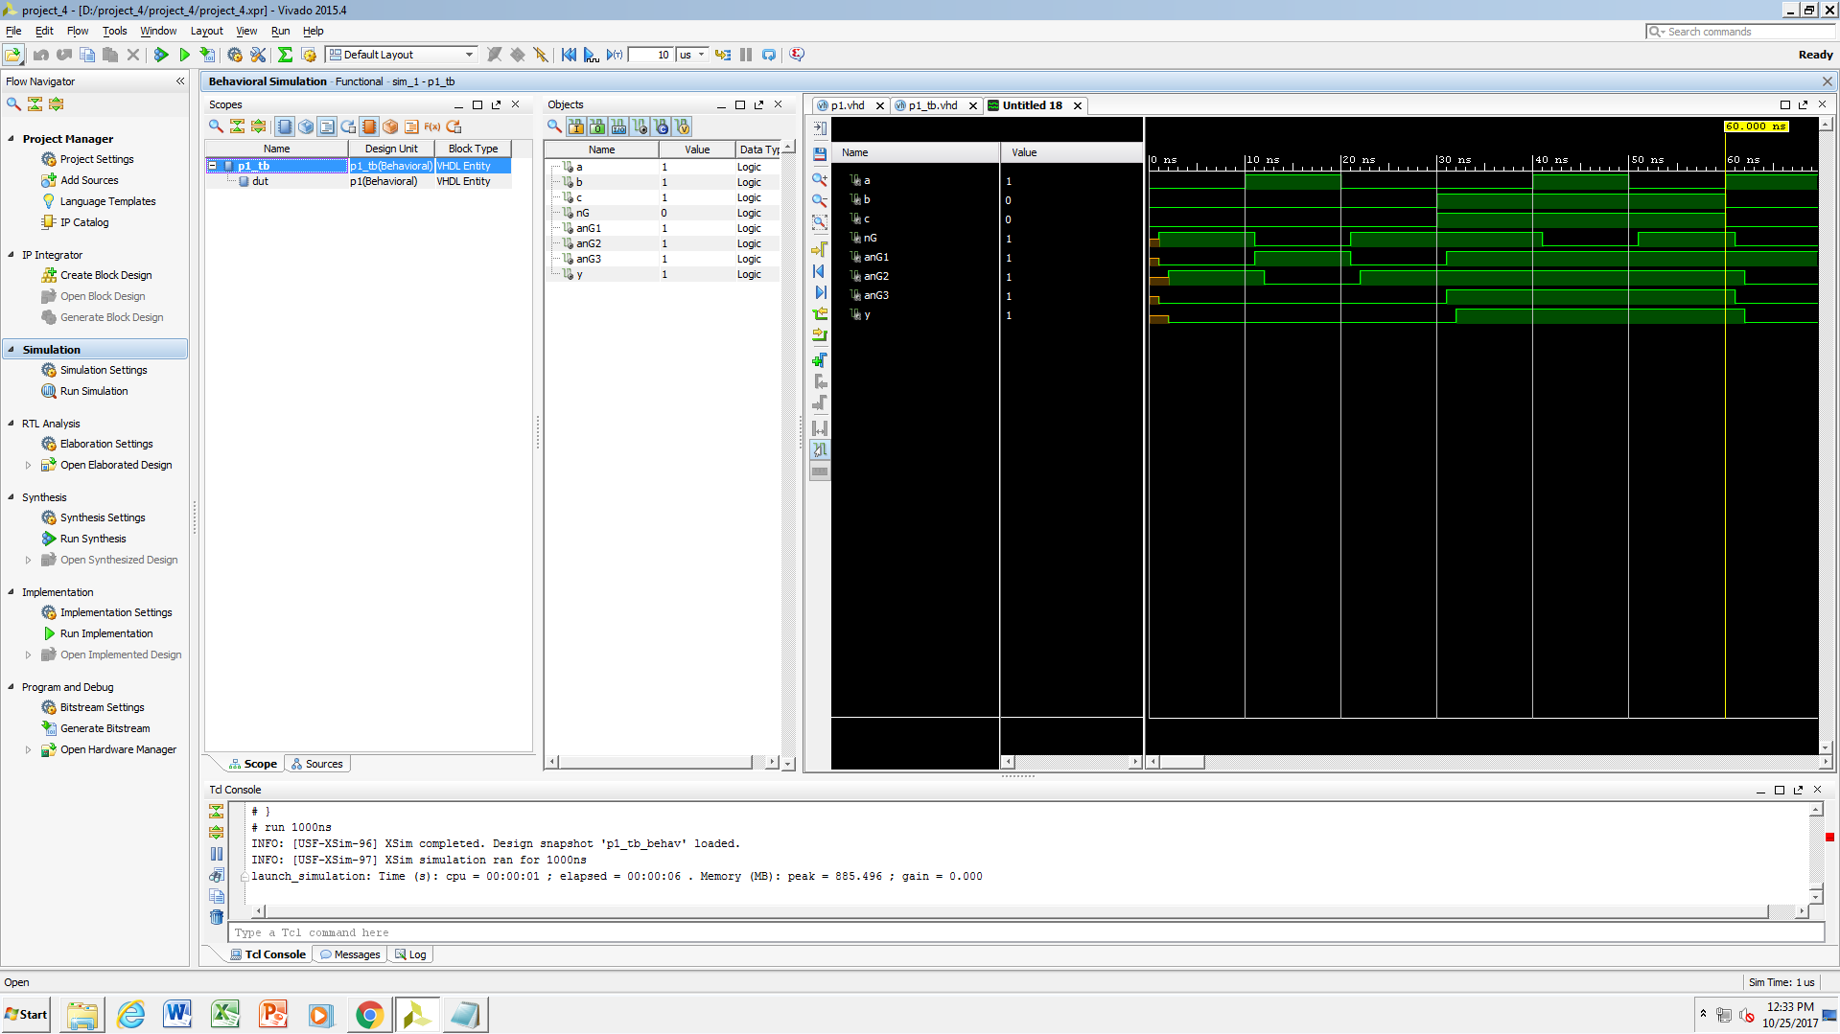
Postlab Questions: (Please use this work sheet to type and print your responses)

- List the references you used for this lab assignment (e.g. sources/websites used or students with whom you discussed this assignment)

- Diligent Real Digital Module 8

- Do you have any comments or suggestions for this lab exercise?

Relatively quick and simple lab, the lack of FPGA simulation makes it rather quick.

